Chapter 7, Problem 21.

In the circuit in Fig. 7.101, find the value of R for which the steady-state energy stored in the inductor will be 1 J.

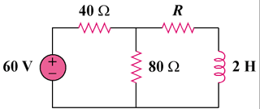

Figure 7.101
For Prob. 7.21.

